 **VELAMMAL BODHI CAMPUS**

**CUMULATIVE EXAM-I (2023-24)**

**Class:X**  **Date : 02.04.2023**

**Time : 3Hrs Marks : 80**

**Sub : Maths**

**General Instructions:**

1.This Question Paper has 5 Sections A-E.

2. Section **A** has 20 MCQs carrying 1 mark each

3. Section **B** has 5 questions carrying 02 marks each.

4. Section **C** has 6 questions carrying 03 marks each.

5. Section **D** has 4 questions carrying 05 marks each.

**6.** Section **E** has 3 case based integrated units of assessment (04 marks each) with sub-parts of the values of 1, 1 and 2 marks each respectively.

7. All Questions are compulsory.

|  |
| --- |
| **I.Section A has 20 MCQs carrying 1 mark each.** |

1. Product of the age of a child five years ago with his age nine years after is 15. His present age is:

(a) 4 years (b) 6 years (c) 5 years (d) None of these

2. The points (– 4, 0), (4, 0) and (0, 3) are the vertices of a

(a) right triangle (b) isosceles triangle (c) equilateral triangle (d) scalene triangle

3. The point A is on positive y - axis at a distance 4 units from the origin. If the coordinates of

B are (– 3, 0) the length of AB is

(a) 7 units (b) 5 units (c) 49 units (d) 25 units

4. The coordinate of a general point on x-axis is of the form:

(a) (x, 0) (b) (0, x)` (c) (x, y) (d) None of these

5. Two of the vertices of a ΔABC are A(–1, 4) and B(5, 2) and its centroid is (0, –3). The coordinates of the vertex C are:

(a) (4, 3) (b) (4, 15) (c) (–4, –15) (d) (–15, –4)

6. The pair of equations 3x+ 2y =5, 2x- 3y = 7 has:

(a) no solution (b) one solution (c) many solutions (d) two solutions

7. If (6, k) is a solution of the equation 3x +y = 22 then, the value of k is:

(a) –4 (b) 4 (c) 3 (d) –3

8. On solving x – y = 3 and, x+ y =5 , we have value of y as:

(a) 1 (b) 2 (c) 3 (d) 4

9. The value of k for which the system of equations 2x + 3y = 5 and 4x + k y =10 has an infinite number of solutions, is:

(a) 1 (b) 3 (c) 6 (d) 0

10. The roots of 3x2 – 7x +4 = 0 are:

(a) rationals (b) irrationals (c) positive integers (d) negative integers

11.If the roots of a quadratic equation are equal, then the discriminant is:

(a) 1 (b) 0 (c) greater than 0 (d) less than 0

12. All the equilateral triangles are ______________.

(a) Similar (b) Congruent (c) both (a) and (b) (d) None of these

13. Given that ΔABC~ΔDEF . If DE =2AB and BC= 3 cm then, EF is equal to ___________.

(a) 12 cm (b) 2 cm (c) 1.5 cm (d) 6 cm

14. If the three sides of a triangle are a, $√3$ a, $√2$ a then the measure of the angle opposite to the longest side is (a) 600 (b) 900 (c) 450 (d) 300

15.If one of the zeroes of the quadratic polynomial (k-1)x2+ kx + 1 is - 3, then the value of k is

(a) $\frac{-4}{3}$ (b) $\frac{4}{3}$ (c) $\frac{-2}{3}$ (d) none of the above

16.The zeroes of the polynomial x2 – 2x – 3 are

(a) – 3 , 1 (b) - 3 , - 1 (c) 3 , - 1 (d) 3 , 1

17.If the graph of a polynomial intersects the x-axis at three points, then it contains ____ zeroes.

(a) Three (b) Two (c) Four (d) More than three

18. There is a circular path around a sports field. Priya takes 18 minutes to drive one round of the field. Harish takes 12 minutes. Suppose they both start at the same point and at the same time and go in the same direction. After how many minutes will they meet ?  
(a) 36 minutes (b) 18 minutes (c) 6 minutes (d) They will not meet

19. If HCF (16, y) = 8 and LCM (16, y) = 48, then the value of y is  
(a) 24 (b) 16 (c) 8 (d) 48

20. The sum of two irrational numbers is always  
(a) irrational (b) rational (c) rational or irrational (d) one

**II. Section B has 5 questions carrying 02 marks each.**

21.Diagonals AC and BD of a trapezium ABCD with AB || DC intersect each other at the point O.

Using a similarity criterion for two triangles, show that  **=**

22. If (1, 2), (4, y), (x, 6) and (3, 5) are the vertices of a parallelogram taken in order, find x and y.

23. Find the value of k for the quadratic equation 2x2 + kx + 3 = 0 , so that it has two equal roots.

24. Solve the system of equation 99x+101y=499 and 101x+99y=501 .

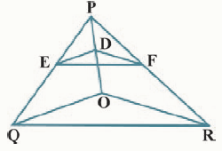

25. In the given figure, DE || OQ and DF || OR. Show that EF || QR.

**III. Section C has 6 questions carrying 03 marks each.**

26. Find a relation between x and y such that the point (x, y) is equidistant from the point

(3, 6) and (– 3, 4).

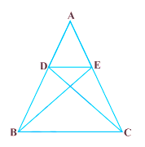

27. In the given figure, if Δ ABE ≅ Δ ACD, show that Δ ADE ~ Δ ABC

28. If the equation (1+m2) x2 +2mcx+ (c2-a2) = 0 has equal roots , prove that c2 = a2 (1+m2).

29. A two digit number is obtained by either multiplying sum of the digits by 8 and adding 1 or by multiplying the difference of the digits by 13 and adding 2. Find the number.

30. If α, β are the zeroes of the polynomial f(x) = 2x2 +5x + k satisfying the relation α2 **+** β2 + αβ **=** , then find the value of k .

31. Find the largest number that will divide 398 , 436 and 542 leaving remainders 7 ,11 and 15 respectively.

**IV. Section D has 4 questions carrying 05 marks each.**

32.State and prove B P T theorem. Using this theorem prove that a line drawn through the mid-point of one side of a triangle parallel to another side bisects the third side.

33. A train travels a distance of 480 km at a uniform speed. If the speed had been 8 km/h less, then it would have taken 3 hours more to cover the same distance. Find the speed of the train.

34. Prove that 3+2 $\sqrt{7}$ is irrational.

35.Draw the graphs of the equations x –2y + 1 = 0 and 2x + 3y – 12 = 0. Determine the coordinates of the vertices of the triangle formed by these lines along the x-axis, and shade the triangular region.

**V.CASE BASED QUESTION.**

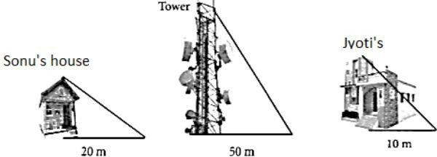36. Read the case study-based questions carefully and answer the following: Jyoti was trying to find the height of tower near her house. She is using the properties of similar triangles. The height of Jyoti's house is 20 m. When Jyoti’s house casts a shadow of 10 m long on the ground, at the same time, tower casts a shadow of 50 m long and Sonu's house casts a shadow of 20 m long on the ground as shown below.

i)What is the height of the tower?

ii)What will be the length of shadow of tower when Jyoti’s house casts a shadow 15 m?

iii)What is the height of the Sonu’s house?

**(OR)**

iv)If tower casts a shadow of 40 m then what is the length shadow of Sonu’s house?

37. A garden is in the shape of rectangle. Gardener grew sapling of Ashoka tree on the boundary of garden at the distance of 1 meter from each other. He want to decorate the garden with rose plants. He choose triangular region inside the park to grow rose plants. On the above situation, gardener took help from the students of class 10th. They made a chart for it which looks as the above figure

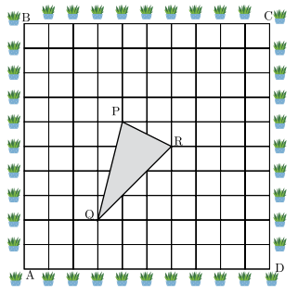

(i)If A is taken as origin, What are the coordinates of triangle PQR ?

(ii) If C is taken as origin, what is the co-ordinate of point P ?

(iii)If B is taken as origin, what are the co-ordinate of P ?

**(OR)**

(iv) What is distance between P and Q if origin is taken A?

38. Priya visited a temple in Gwalior. On the way she sees the Agra Fort. The entrance gate of the fort has a shape of quadratic polynomial (parabolic). The mathematical representation of the gate is shown in the figure.

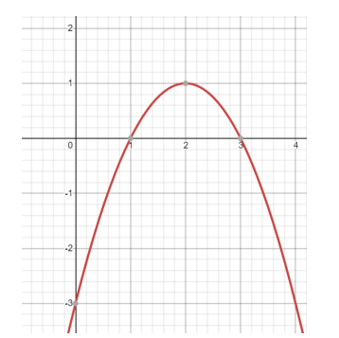

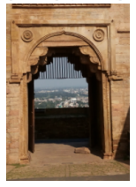

Based on the zeroes of the polynomial represented by the graph.

(i)Find the zeroes of the polynomial represented by the graph.

(ii) What will be the expression for the polynomial represented by the graph?

(iii) What will be the value of polynomial, represented by the graph, when x = 4?

**(OR)**

(iv) If one zero of a polynomial p(x) is 7 and product of its zeroes is -35, then p(x) =